SIT
Tested Date |  | Issue scenario |  | Response
Installation
11/09/16 | Android | New request by Ms Sit to rename Acacia instead of Marketplace  - Sample screenshot; splash screen, login page, etc   & 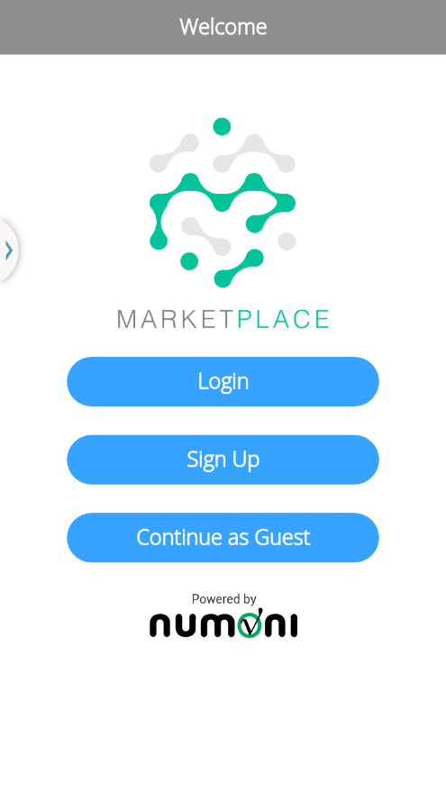 |  | [Valen] Please refer to the following row.
 | IOS | Same issue as IOS  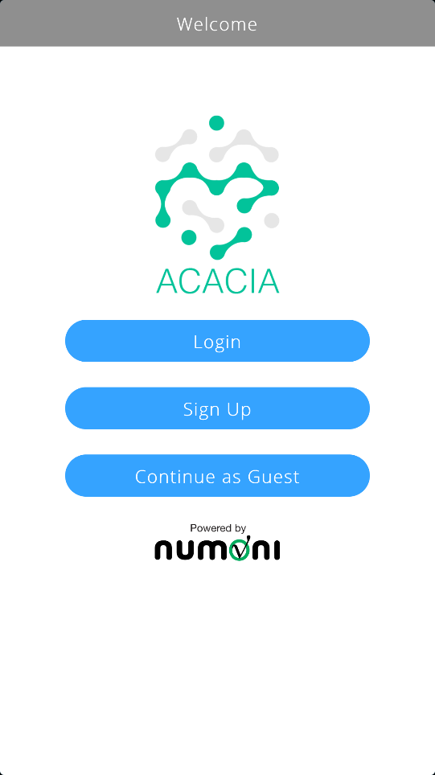 |  | DONE
13/09/16 | Android/IOS | - Rename the application icon to Acacia  - Stick to the same font size as original Splash screen & home page.  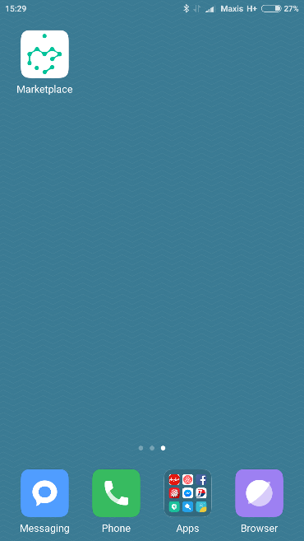 > 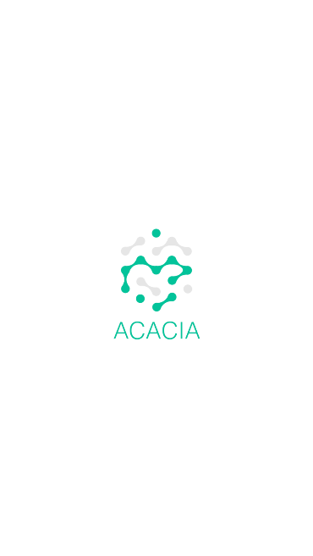 > 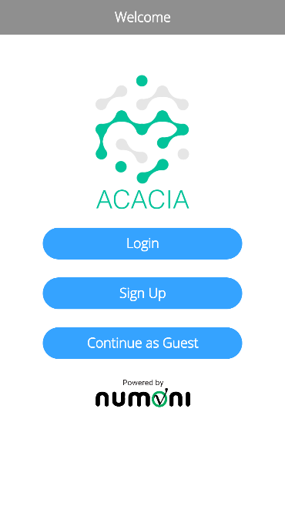  - Same issue as IOS  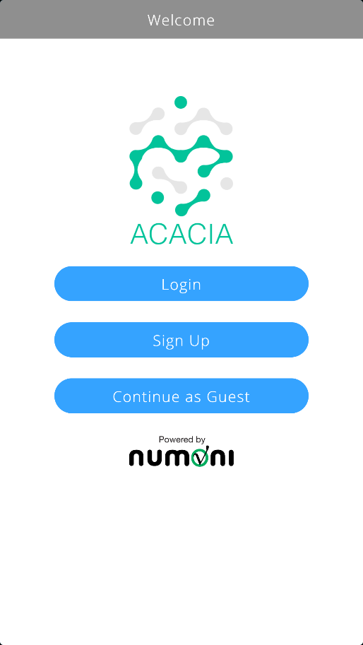 |  | DONE
 | Android/IOS | Tab [App] > Splash Screen > Home > Header  - Please refer to the UI via google drive https://drive.google.com/drive/folders/0B9oOsWhCXi98LVNDT2UxQ3Q2Z0k  - Please confirm other screens the same header as stated in the google drive.  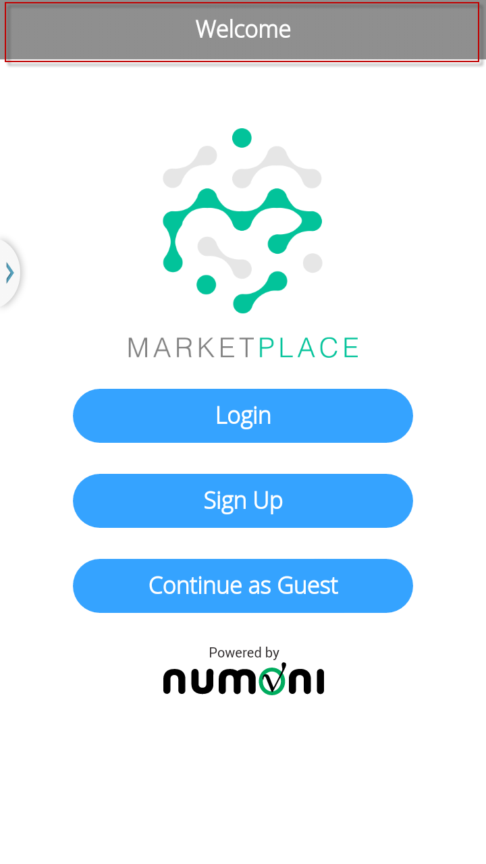  - If the title header has to be there, please ensure all the screens are consistency. Found my profile, chat feedback, search without the same header design. |  | Ok. Will switch profile, chat feedback, and search to have same header design.  [Valen] Please refer to the following row.  DONE – I removed the header for Home/Splash Screen. Other screens will share the same grey header.
14/09/16 | IOS | Login > cursor incorrect position; email & password  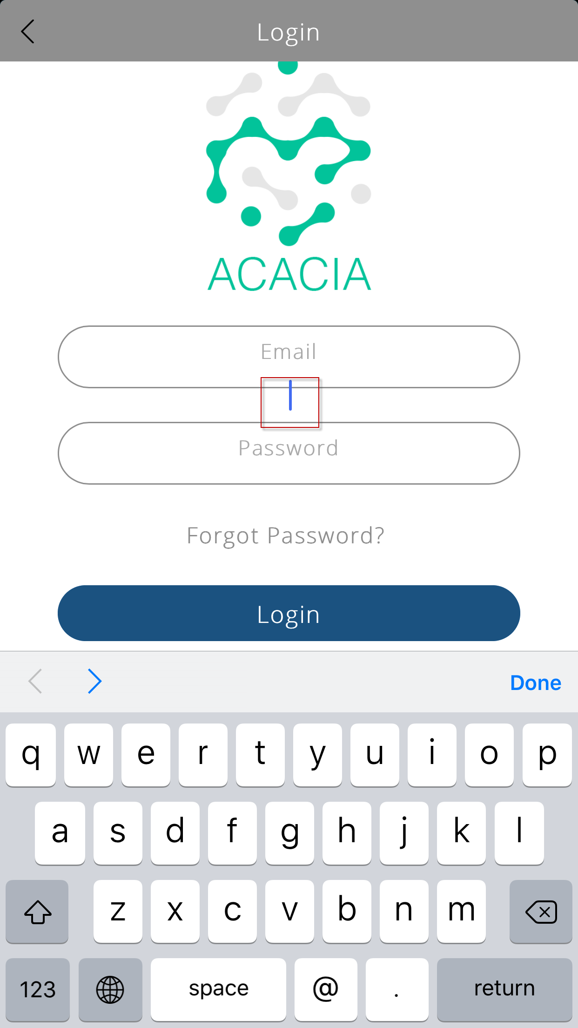 |  | DONE (IOS 10)  BELOW IOS 10:  http://stackoverflow.com/questions/23431633/when-scrolling-the-cursor-follows-the-scroll-instead-of-staying-in-a-field-on-i  http://stackoverflow.com/questions/20737503/mobile-safari-input-caret-does-not-scroll-along-with-overflow-scrolling-touch  https://bugs.webkit.org/show_bug.cgi?id=138201  http://openradar.appspot.com/18819624  This is a bug from Apple’s webkit implementation, and there is currently no workaround. I have tried the ‘hacked’ solutions, but they did not work.
13/09/16 | Android/IOS | Login > My Profile > Add Credit > to remove the header if no title  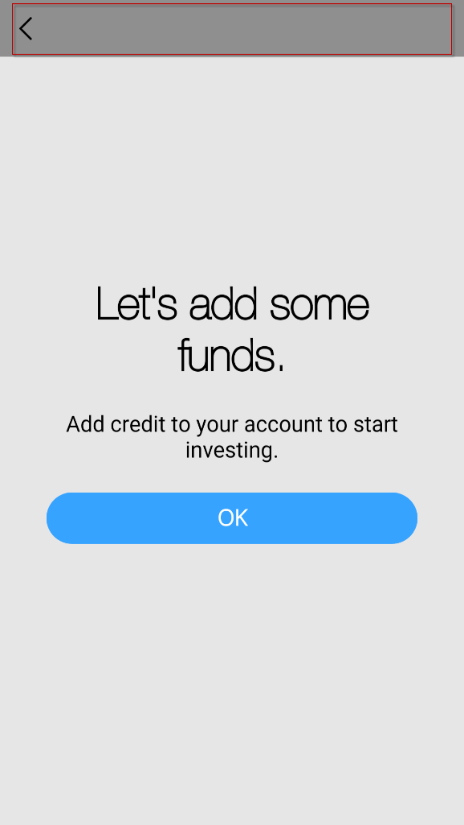  Login > Chat Feedback > The title header design is inconsistency with other screens.  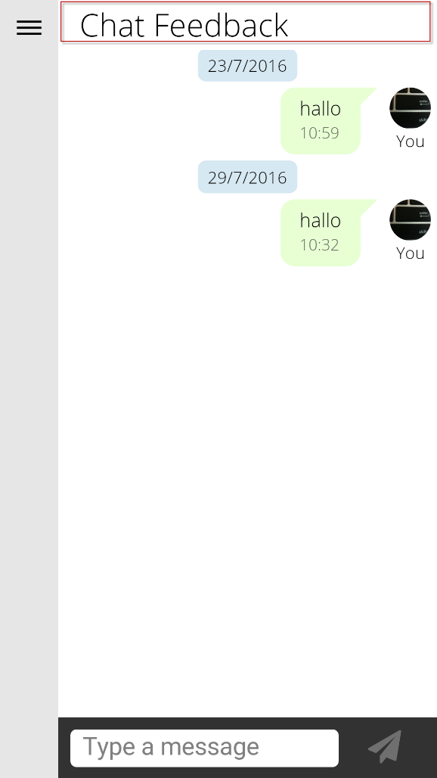 |  | DONE
14/09/16 | IOS | Login > My Profile > Add Credit > to remove the header if no title  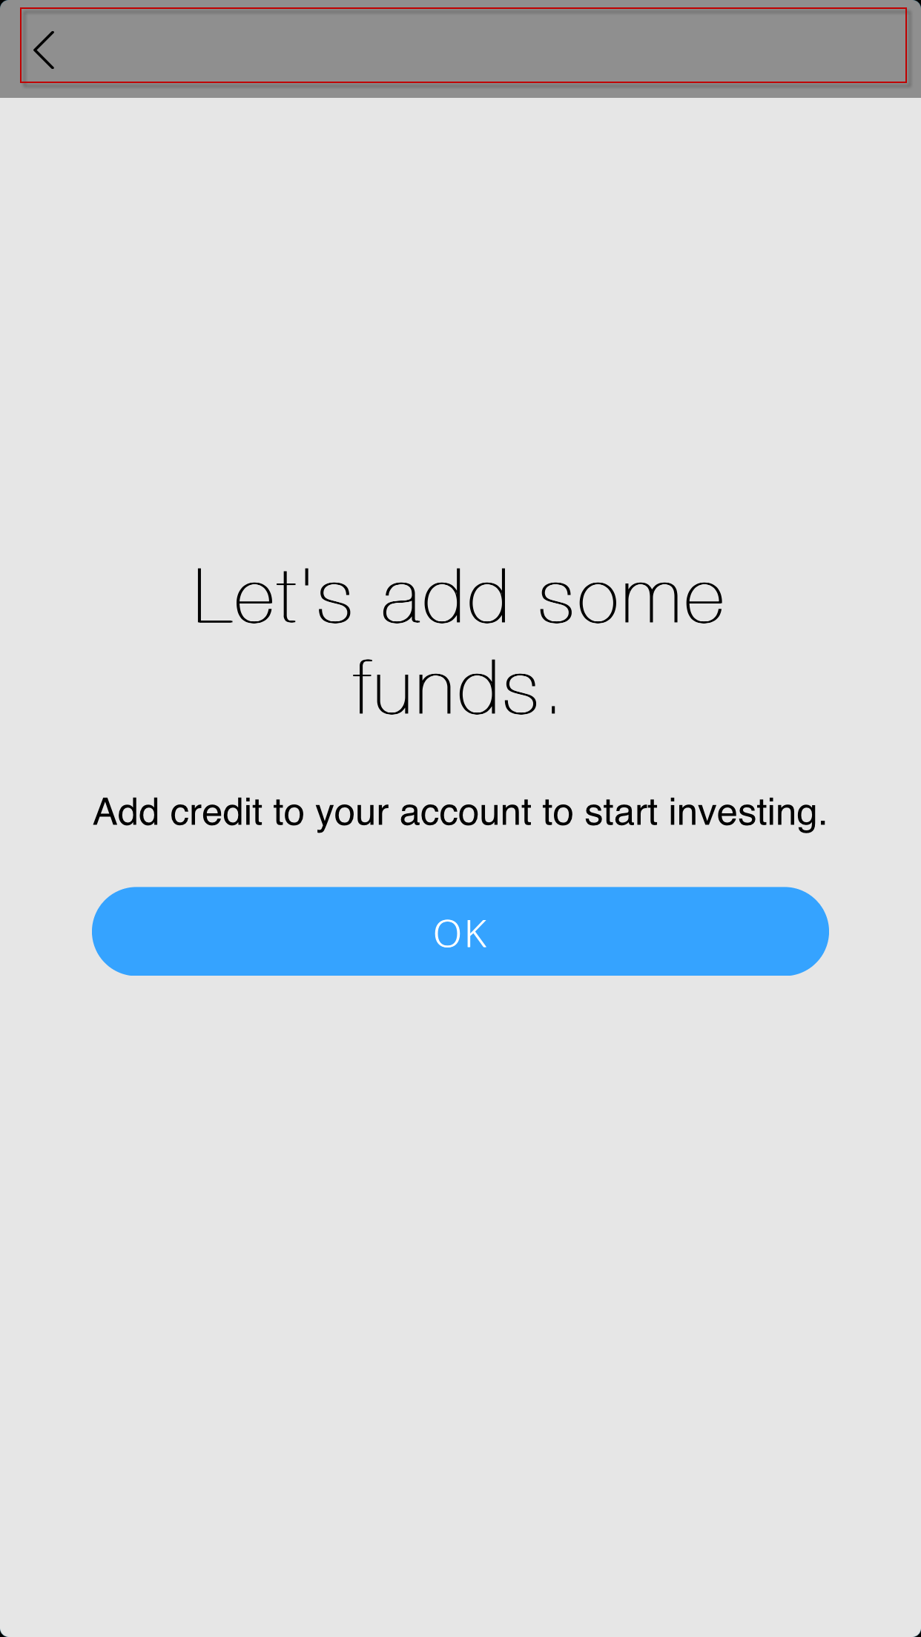  Login > Chat Feedback > The title header design is inconsistency with other screens.  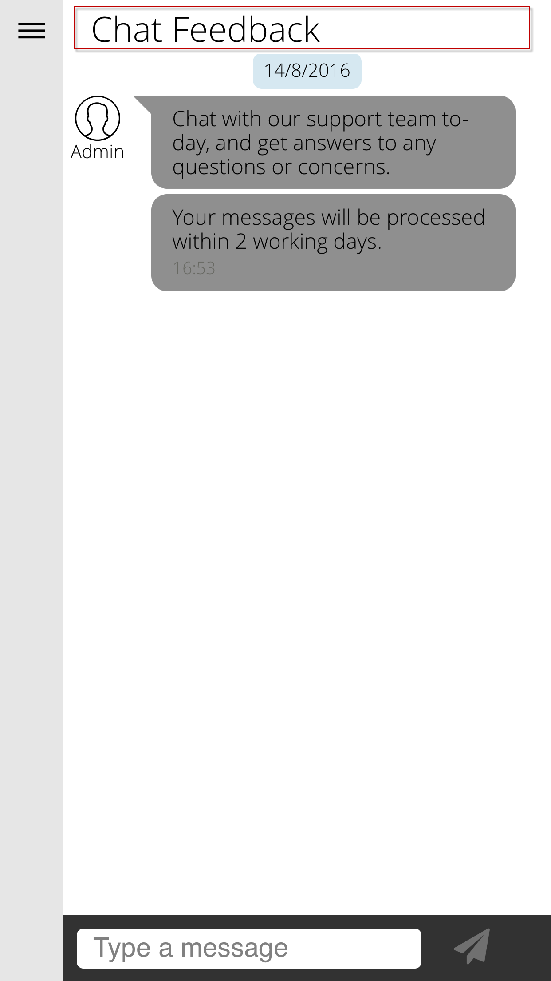 |  | DONE
14/09/16 | Android/IOS | Login > My Profile > Add Credit > Let’s add some funds > OK > Add Credit page displayed = OK  - Slide Menu > Add Credit Now > Add Credit page displayed = Make amendment.  - Same as IOS  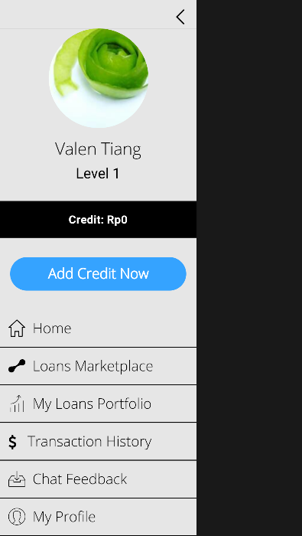 > 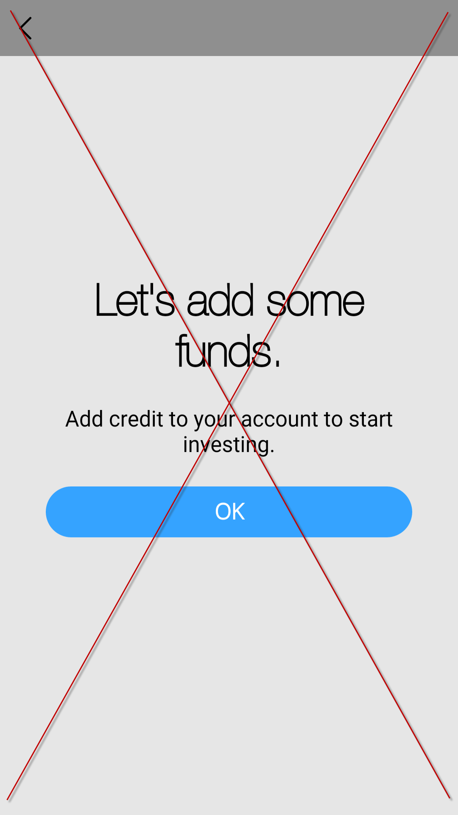 > 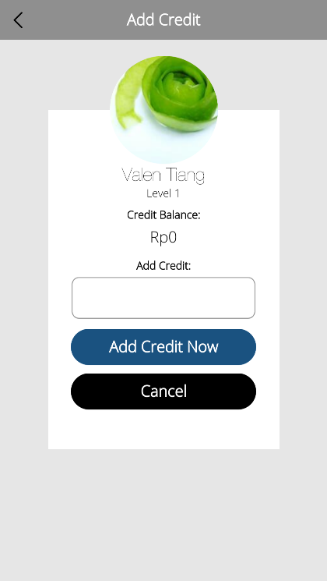 |  | DONE
14/09/16 | IOS | Login > My Profile > Missing Photo  Username: mikitiang@hotmail.com; password: 123456  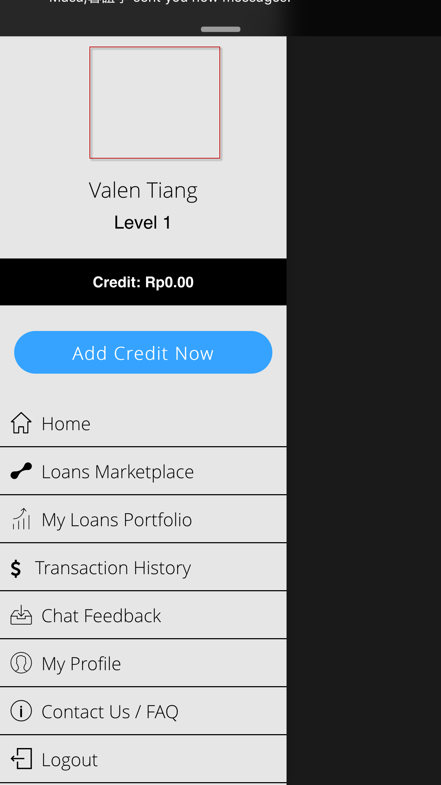 |  | API url issue. Will be resolved when we host all API calls on public urls. Right now, the api url when run in Numoni, has issues resolving itself.  We are now mixed in using Public URL, and INTRANET URL.
Sign Up
26/08/16 |  | Sign-Up > Country field > Remove country default by putting ‘Please Select’.  [13/09/16] Remove the country flag when default value is ‘Please Select’.  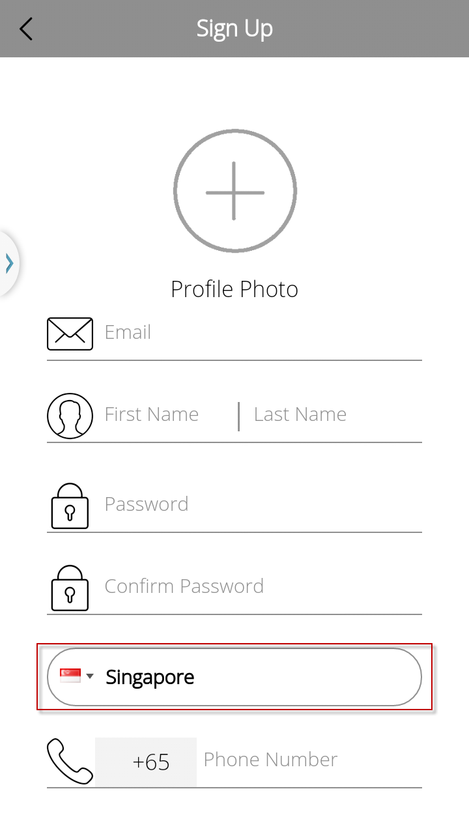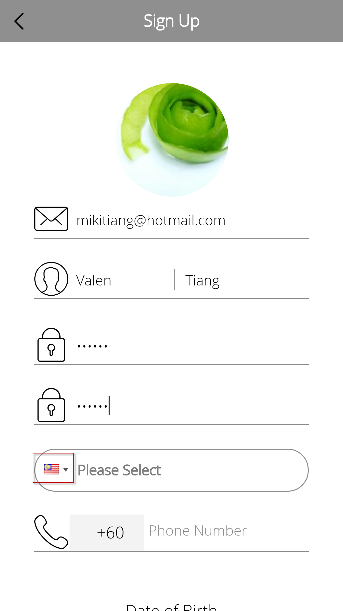  [14/09/16] Same issue as IOS  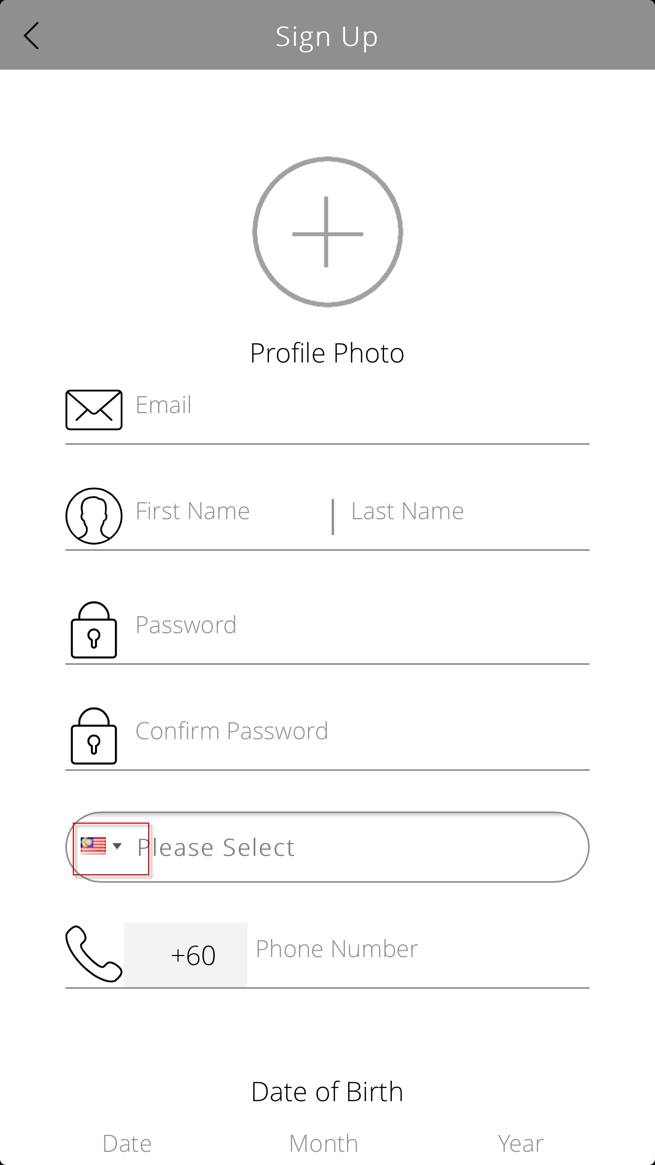 |  | DONE (IOS 10)  BELOW IOS 10:  http://stackoverflow.com/questions/23431633/when-scrolling-the-cursor-follows-the-scroll-instead-of-staying-in-a-field-on-i  http://stackoverflow.com/questions/20737503/mobile-safari-input-caret-does-not-scroll-along-with-overflow-scrolling-touch  https://bugs.webkit.org/show_bug.cgi?id=138201  http://openradar.appspot.com/18819624  This is a bug from Apple’s webkit implementation, and there is currently no workaround. I have tried the ‘hacked’ solutions, but they did not work.
14/09/16 | IOS | Home > Sign Up > Cursor incorrect position found  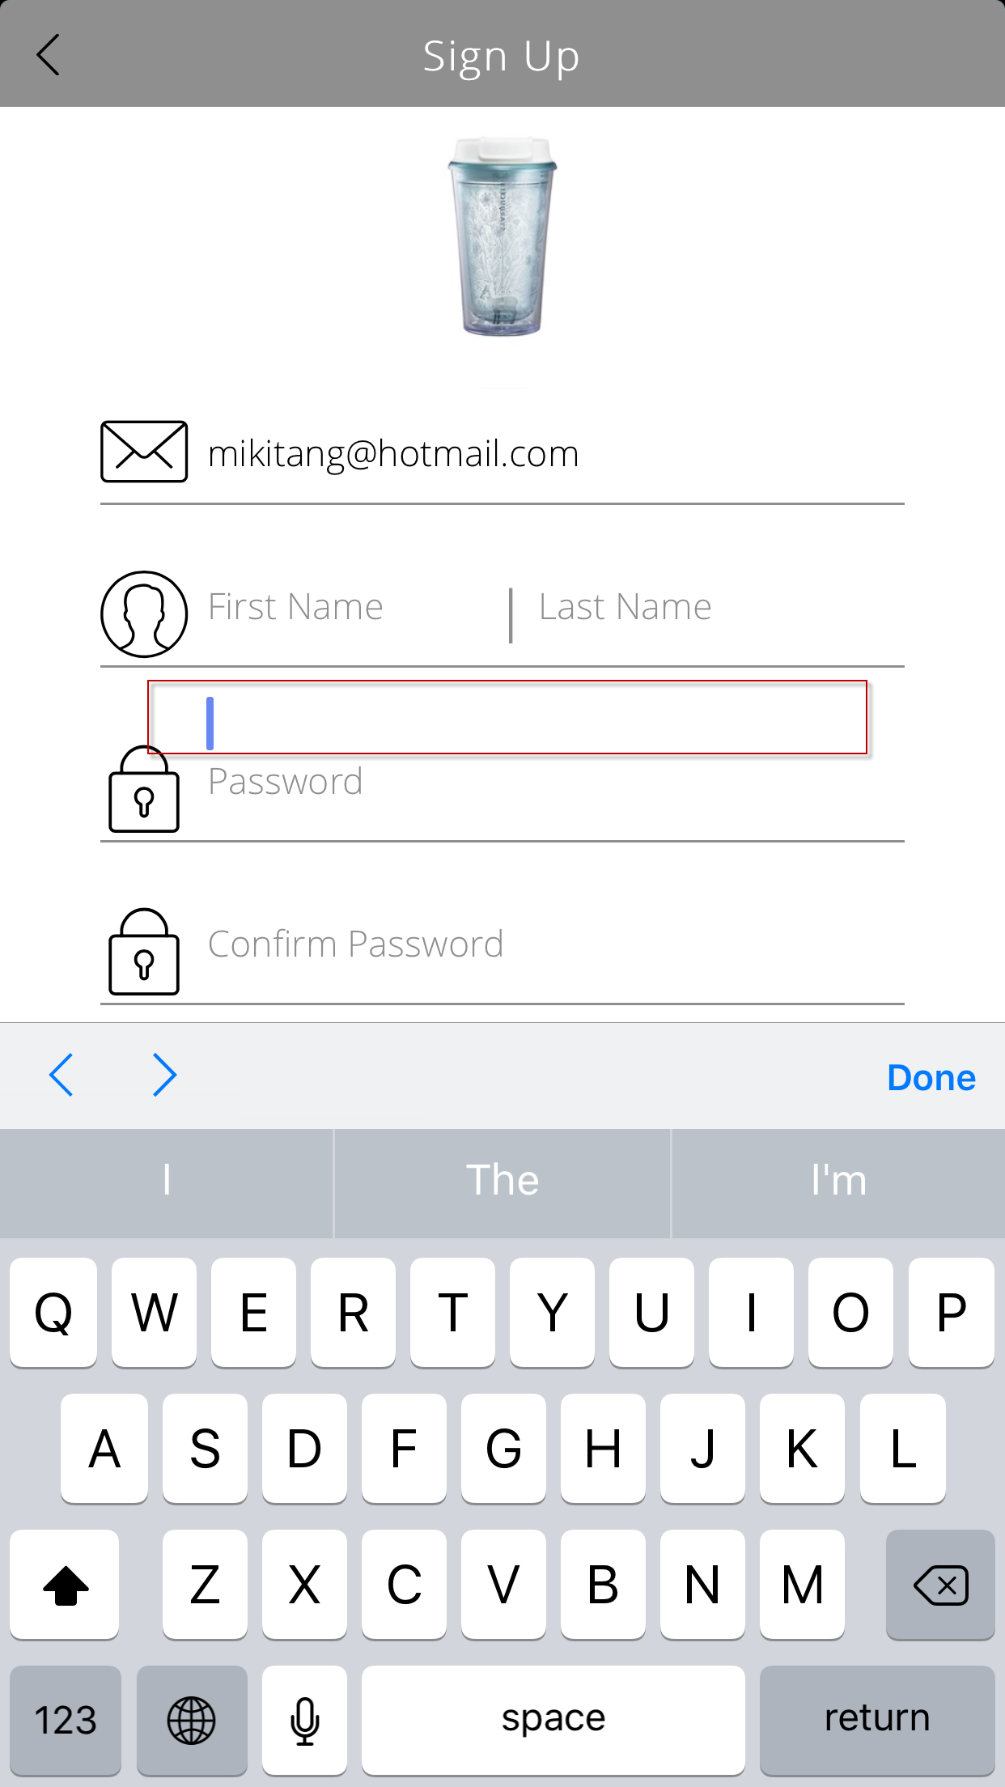 > 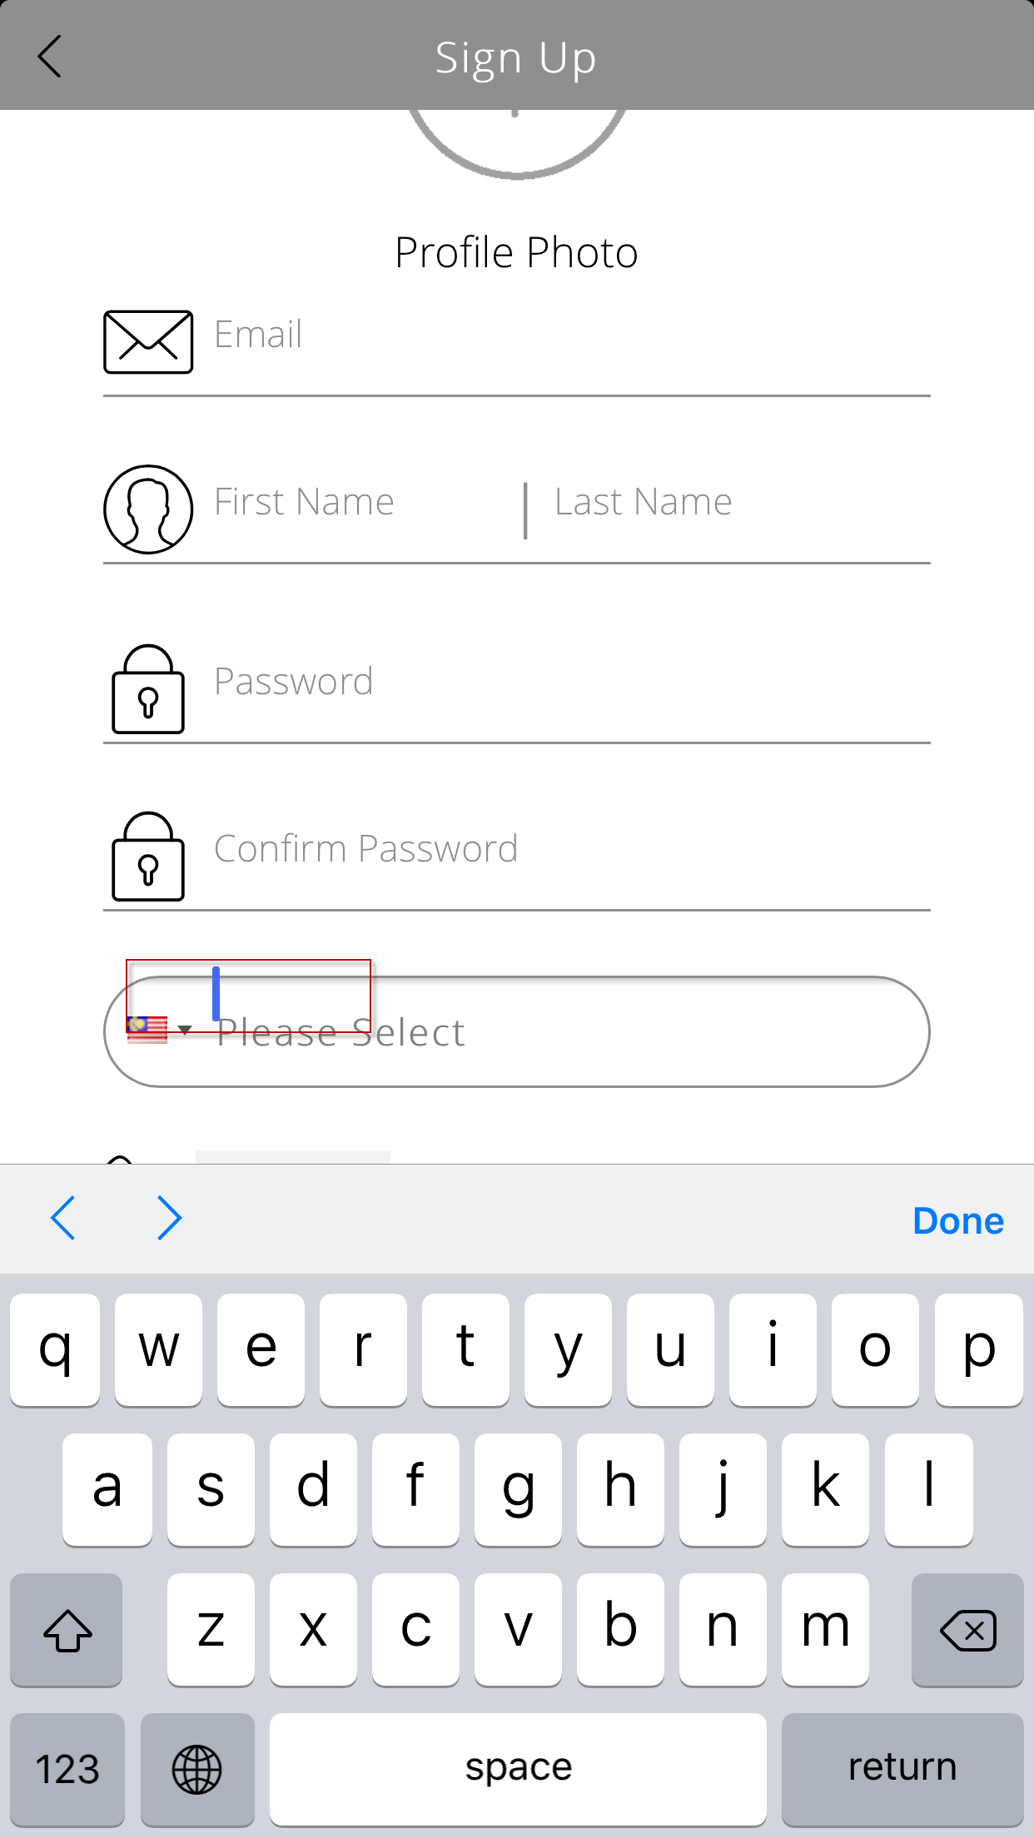 |  | DONE
13/09/16 | Android/IOS | Sign-Up> Fill in necessary fields > Next > Message prompted ‘Sorry, we are unable to connect…’  If the email address being registered, the status response should be different. Please refer to the Sequence diagram for detail. |  | Yes, the response for duplicated signup is  “Sorry, your registration was invalid.  Please contact us for assistance.  ”  For unsuccessful messages that failed to be sent to server and returned, we get ‘Sorry, we are unable to connect…’. I verified this in the codes.
  Status: 400 Bad Request
  Status: 200 OK
  a. Status = 000, Message = Successful
  b. Status = 400, Message = Failed
  a. Status = 300, Message = Duplicated
11/09/16 |  | Sign Up > Underline pattern & colour inconsistency  [13/09/16] DOB underline colour differ with others.  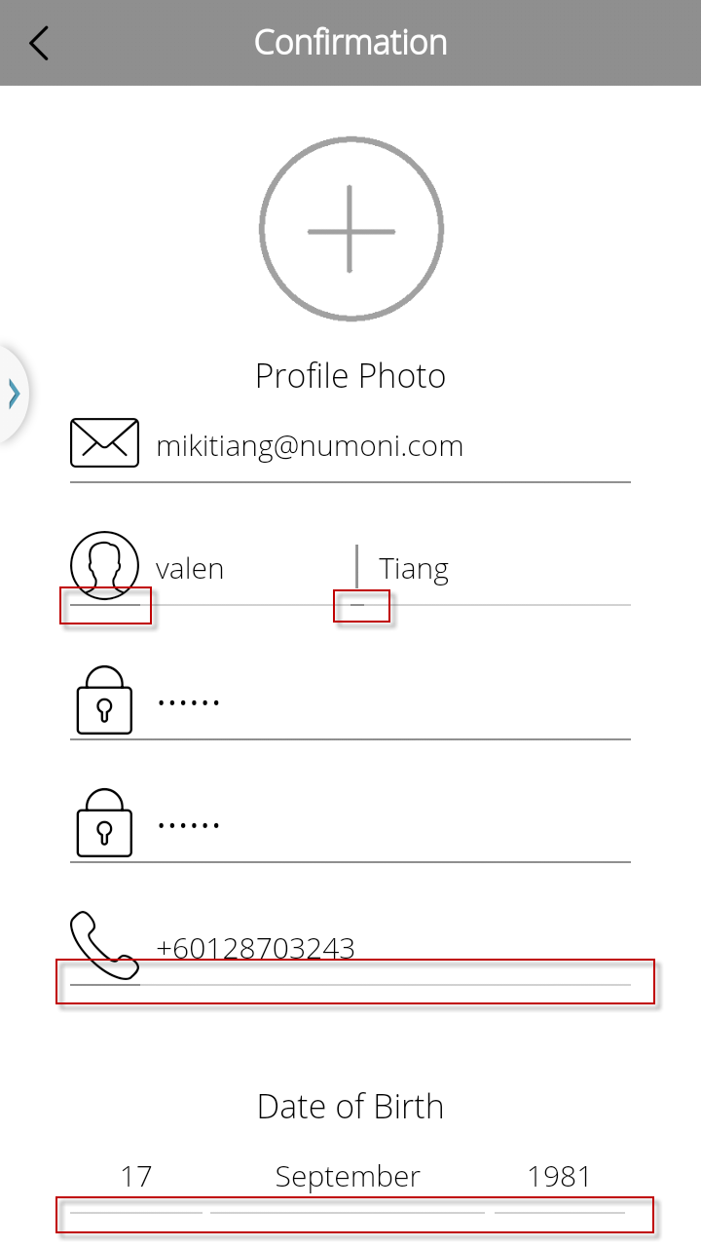[13/09/16] 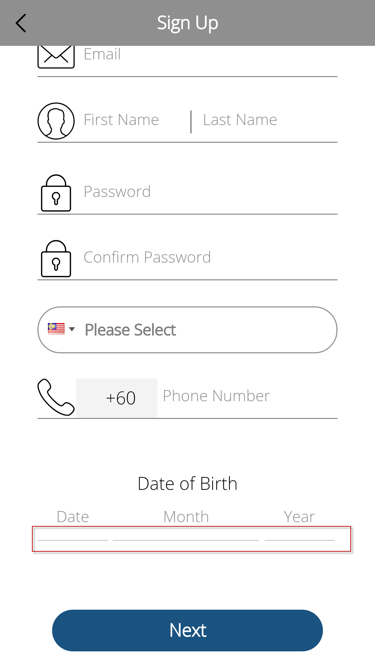 |  | DONE
Login
13/09/16 |  | Login > Slide Menu  - Line found.  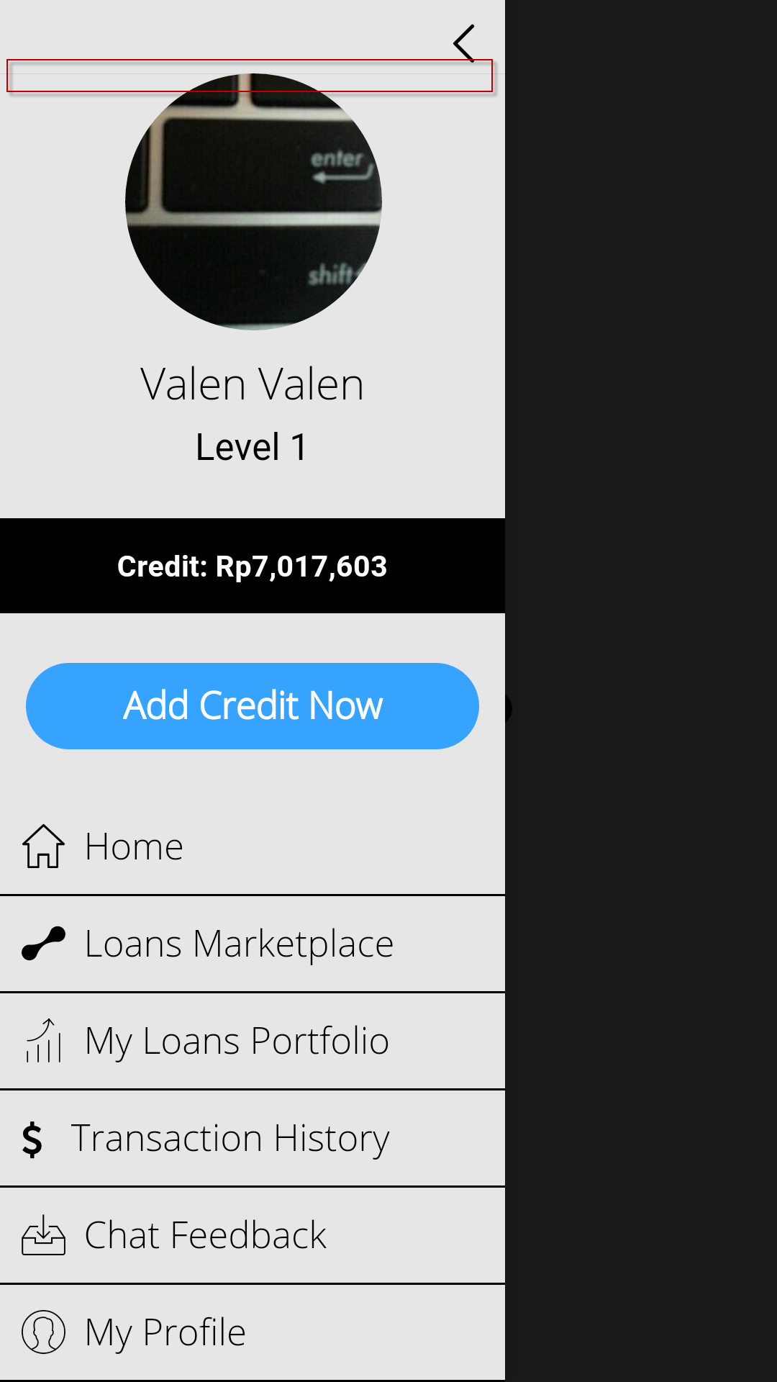 |  | DONE
14/09/16 | IOS | - Same issue as IOS  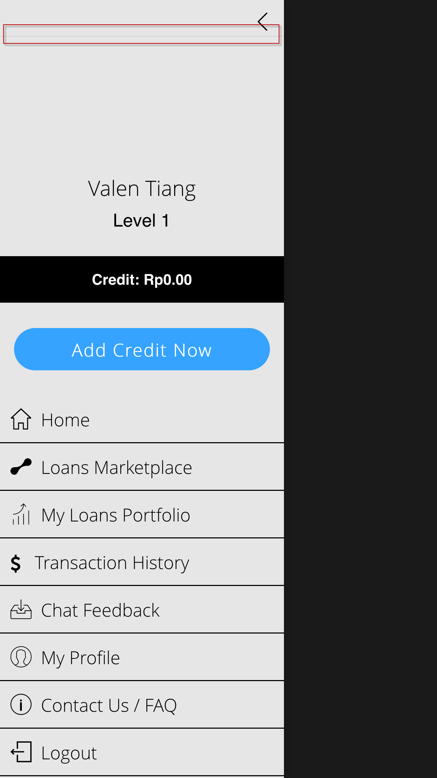 |  | DONE
11/09/16 |  | Login > My Profile> Insufficient length to display DOB  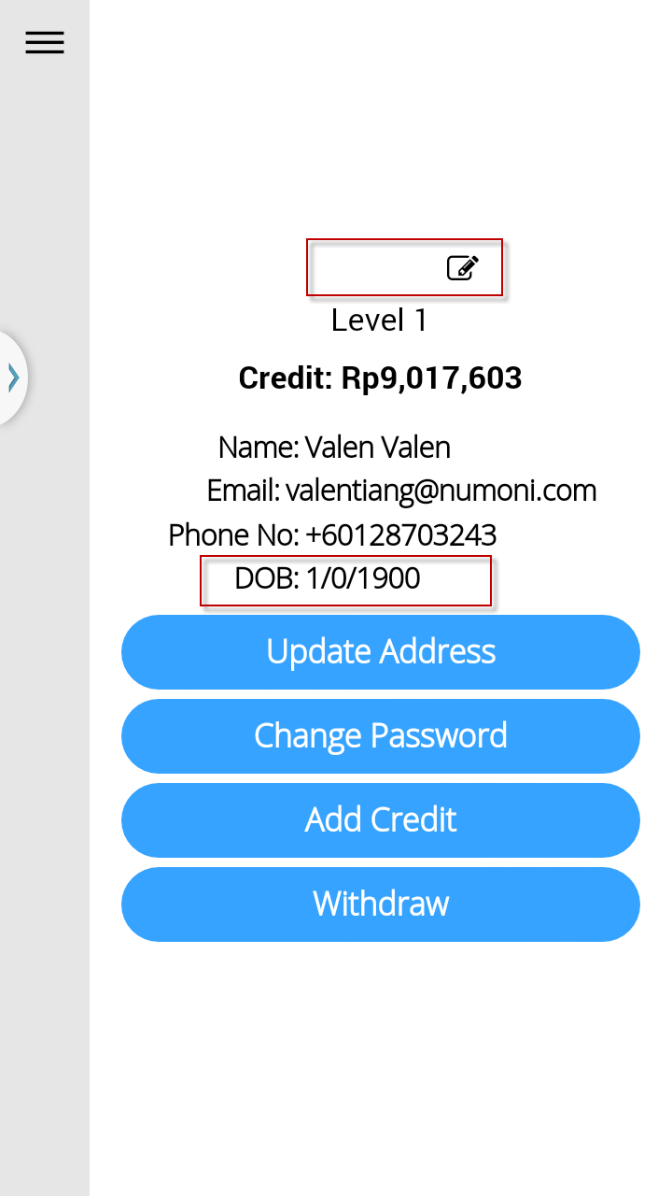 |  | Date of birth error value received from server side.  [Valen] Please refer to the following row.  Date is minimum possible date set by server.  [Valen] What does it mean by minimum possible date?  ----- > 1 January, year 1900  Profile photo is not showing, because of API URL issue.  [Valen] It was working now, may I know what the issue of API URL is. Please specify.  API url issue. Will be resolved when we host all API calls on public urls. Right now, the api url when run in Numoni, has issues resolving itself.  We are now mixed in using both Public URL, and INTRANET URL.
13/09/16 |  | Login > My Profile > The title header should be ‘My Profile’  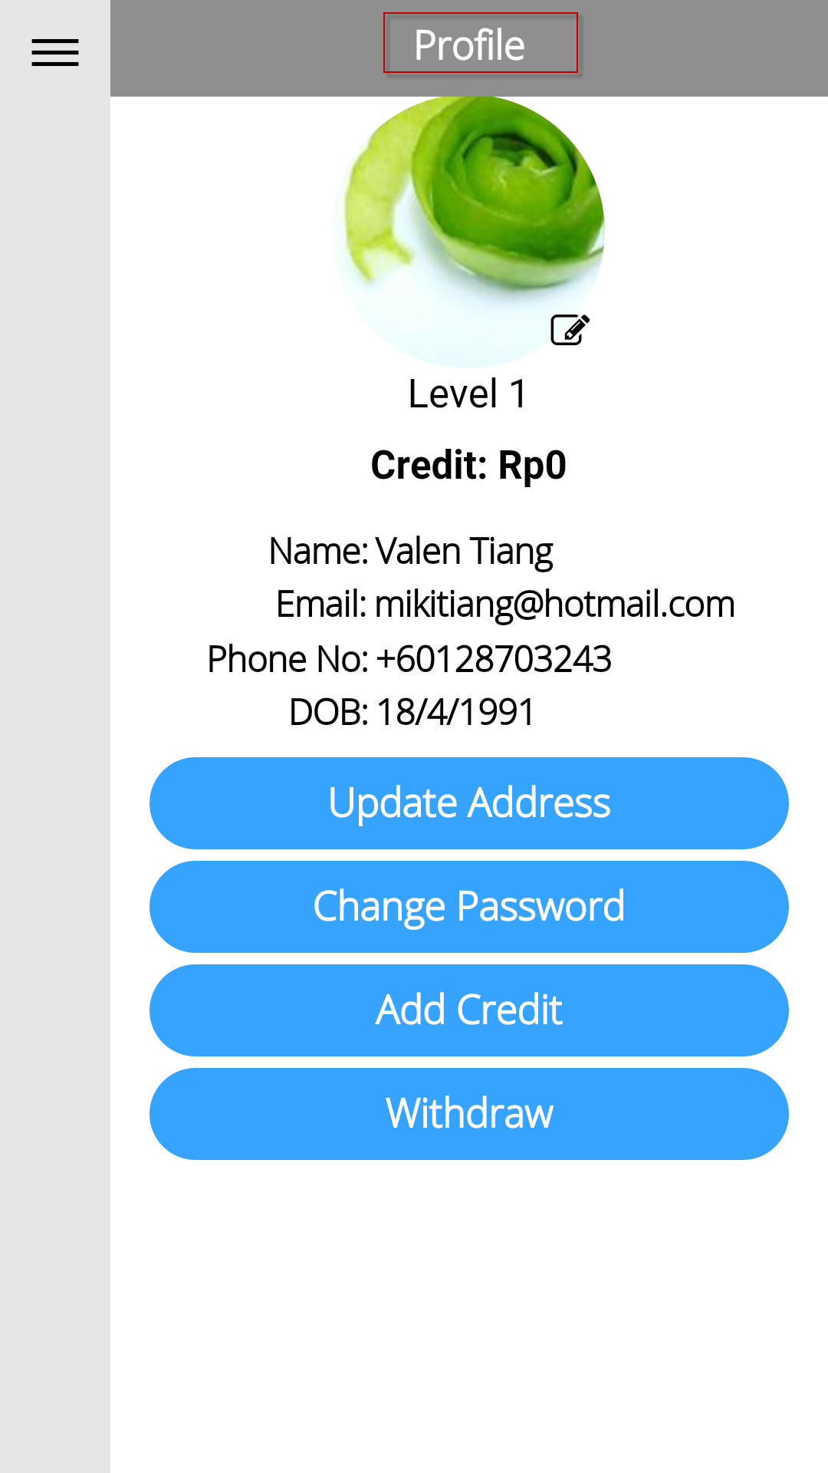 |  | DONE
14/09/16 | IOS | - Login > My Profile> Insufficient length to display DOB  - Login > My Profile > The title header should be ‘My Profile’  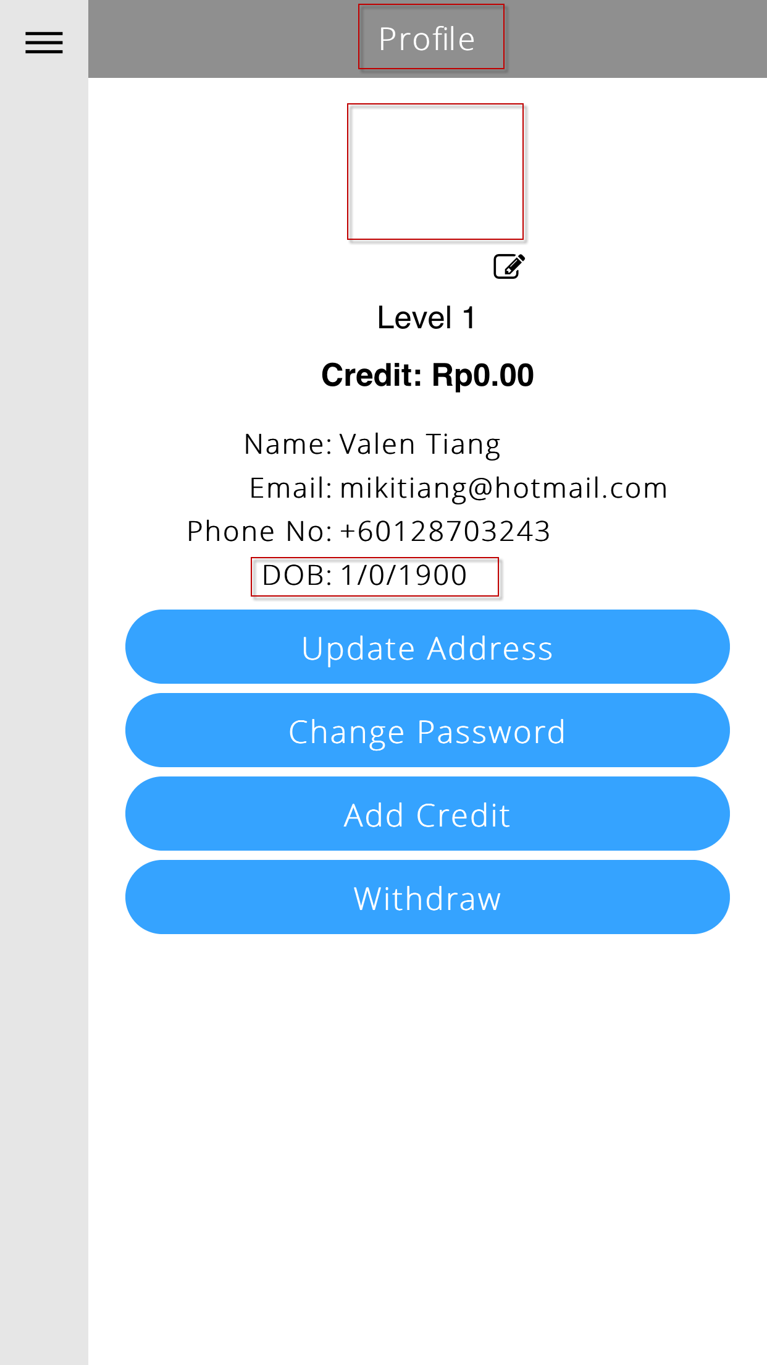 |  | DONE
 |  | Login > My Profile > Registered DOB (18/05/1991) differed from the My Profile (18/04/1991), API queried correct value (18/05/1991) as registered.  > Sign-Up Registration > My Profile > API data queried from backend  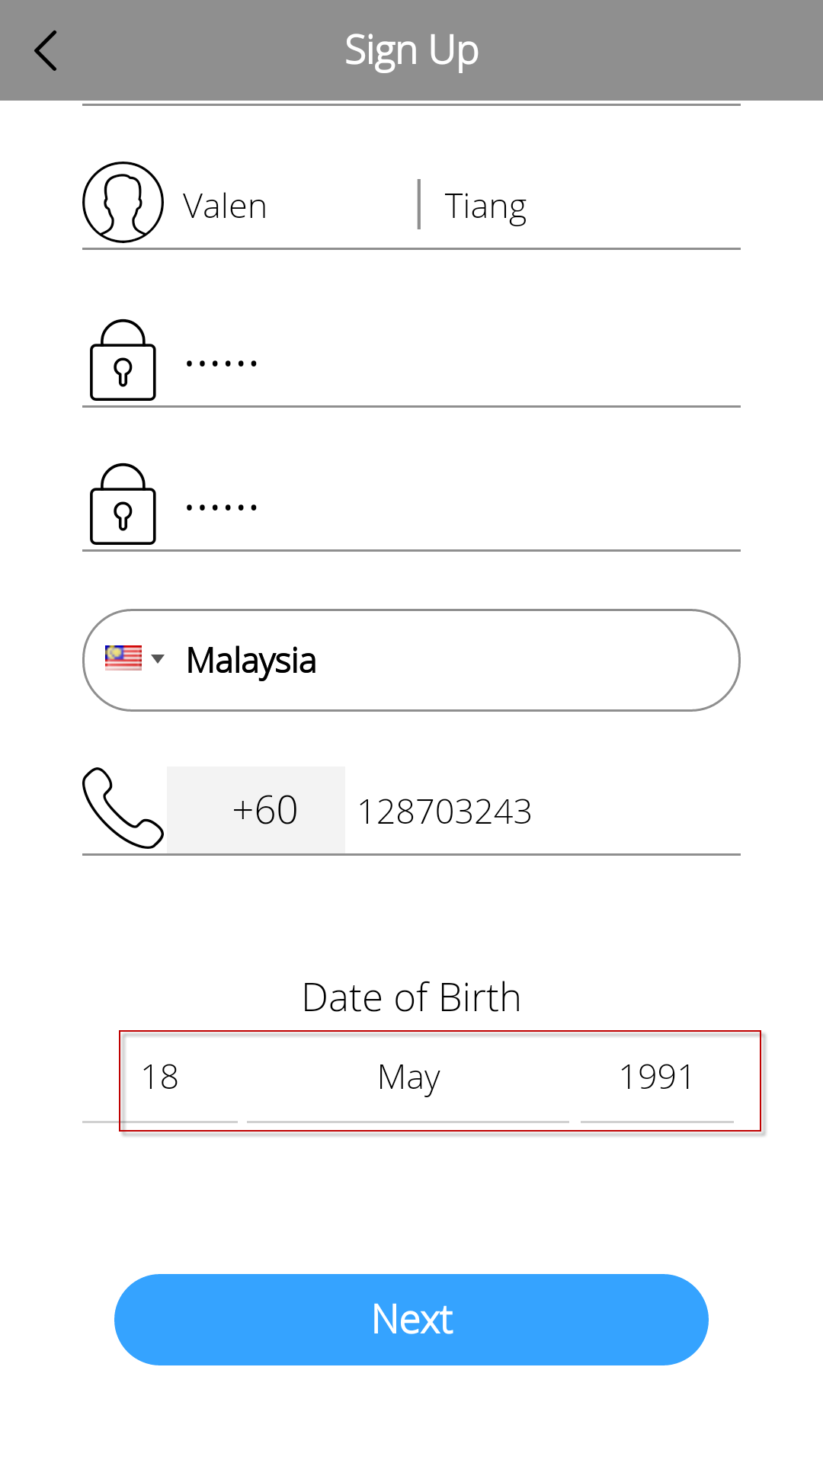> 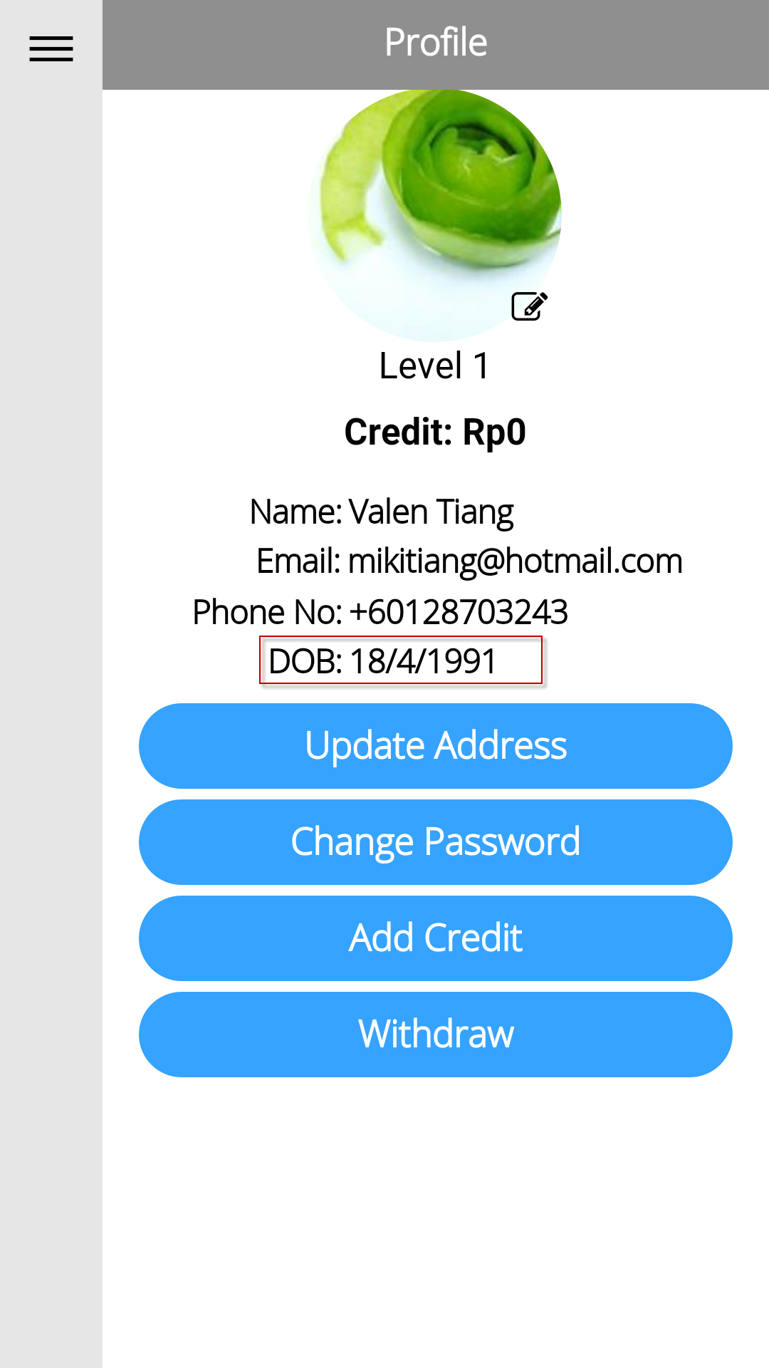 > 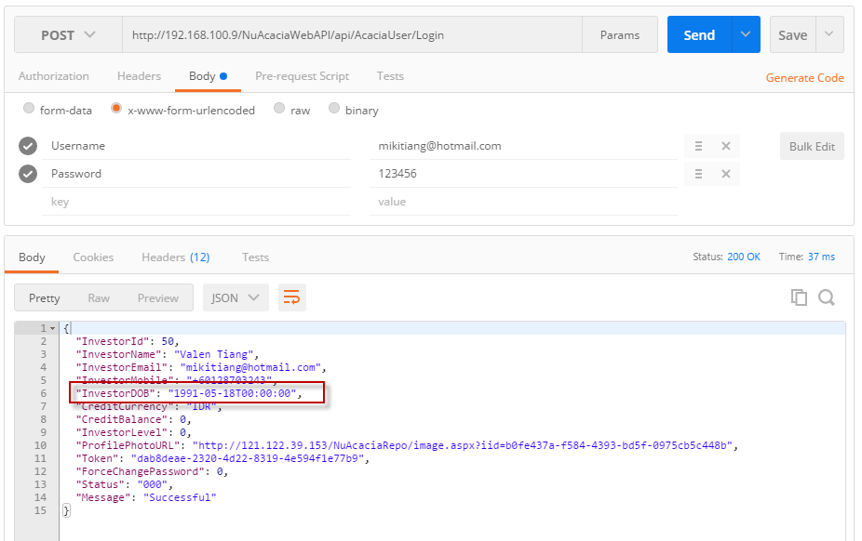 |  | DONE
 |  | Login > My Profile > DOB format to DD/MM/YYYY  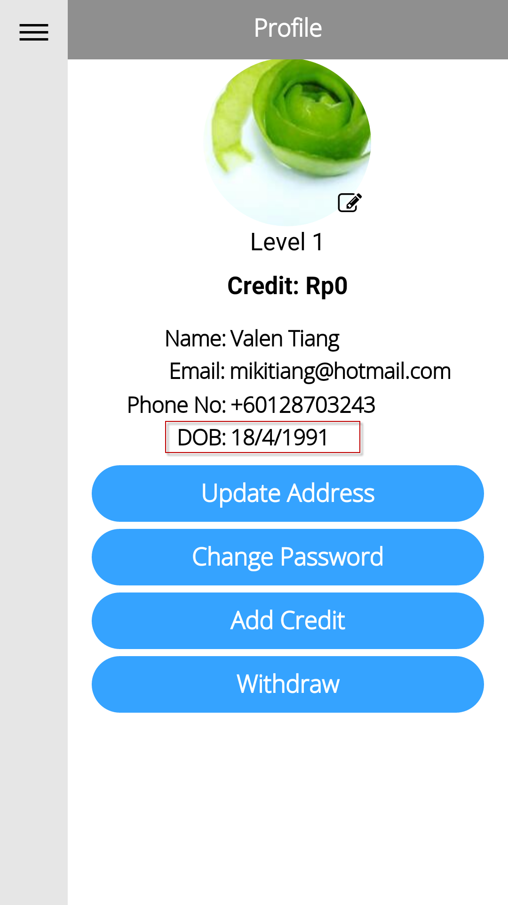 |  | DONE
26/08/16 |  | Login > My Profile > Update Address  - Auto complete method applies to Country & City, make the same as State for consistency.  [13/09/16] No auto complete function found to the field of State/Province.  - Label of Please Input City is not consistency with the field: District/Town/City.  [13/09/16] Please change the label to Please Input District/Town/City.  [13/09/16] Default value of District/Town/City – Please Select; apply to State.  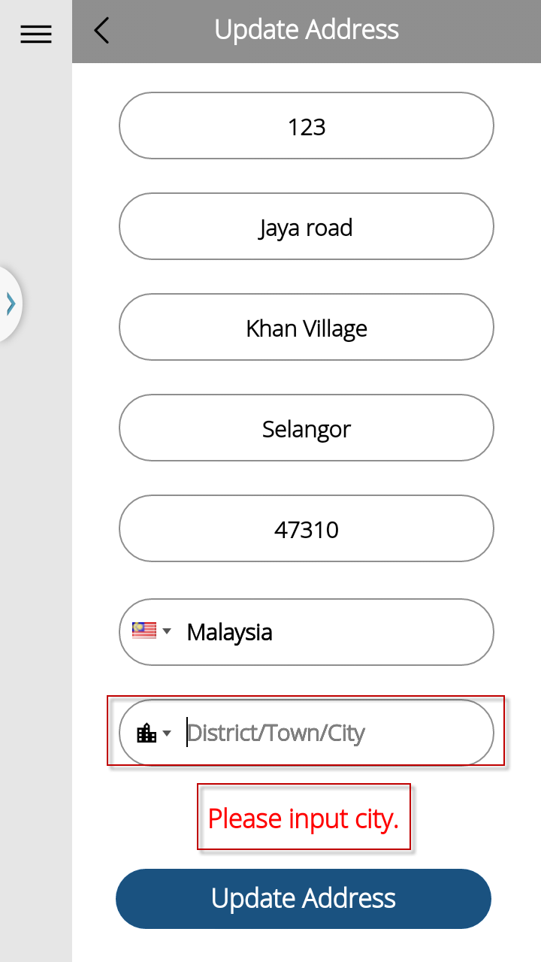  - Please re-arrange the field order as sequence diagram.  [13/09/16] Please re-arrange the field order as sequence diagram.  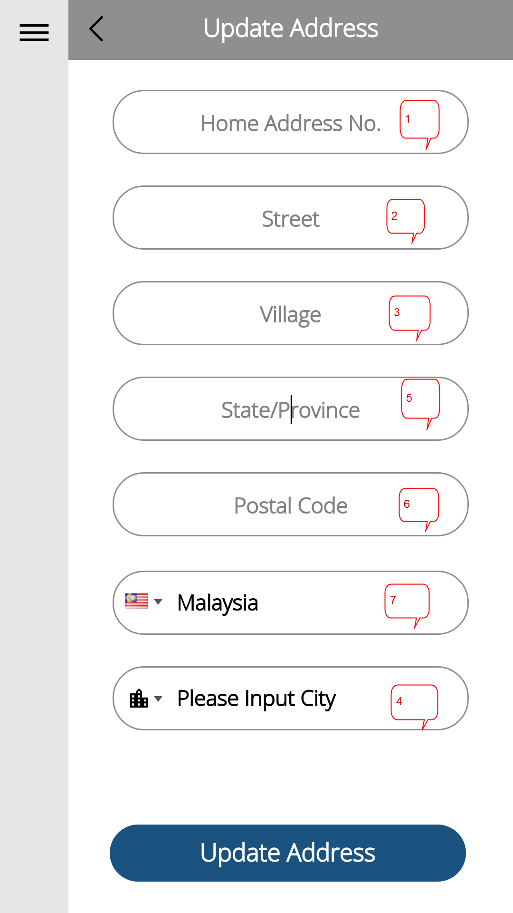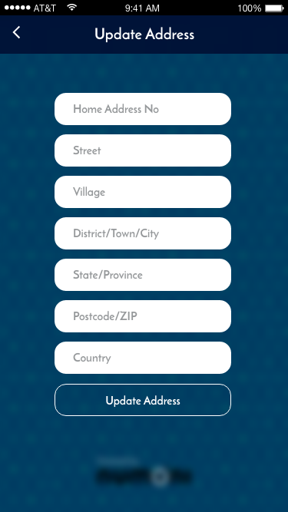 |  | Part 1 - DONE  Part 2 –  We cannot rearrange the field order as per the diagram exactly, because we need to fill in COUNTRY FIRST, before CITY.  Therefore, I left the COUNTRY AND CITY inputs as the last 2 inputs, because they are of the same type of input (dropdown/predictive). The rest are wildcard text input.
 |  | Login > My Profile > Add Credit > Fill in Rp70,000 > Add Credit Summary > Select Payment Type > Credit Card > Failed to redirect to mock-up payment gateway > Add credit successfully.  - The screen is not the same as UI  - The payment gateway redirect to a website news.  - No integration to mock up payment gateway API.  - User Tab [Pay] without Select Payment Method, should prompt an alert message.  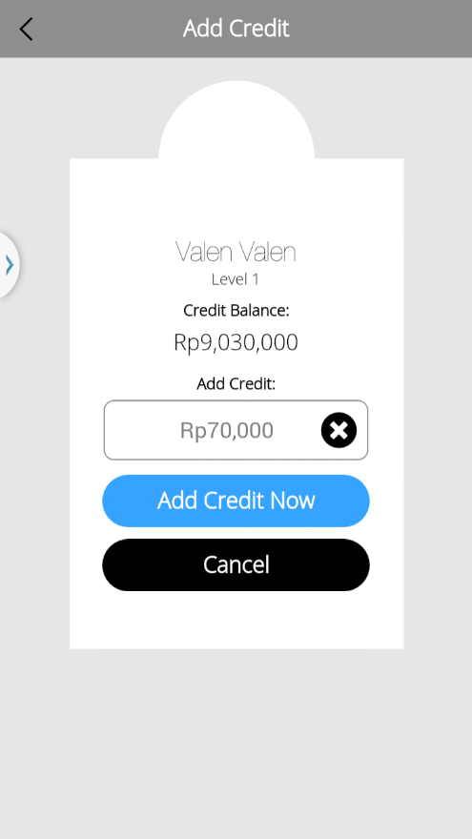 > 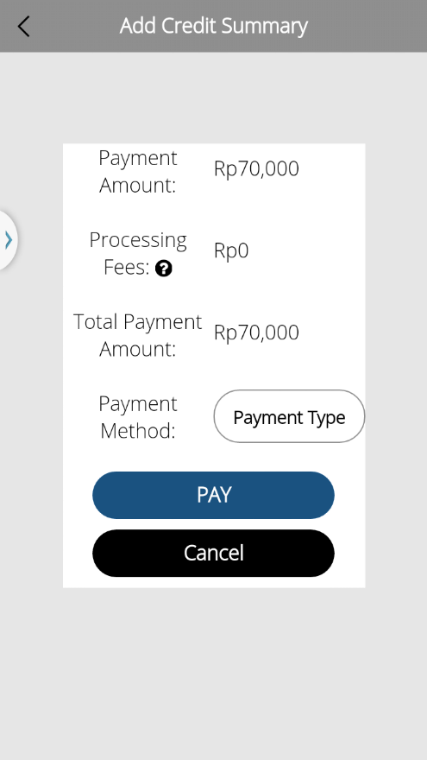 > 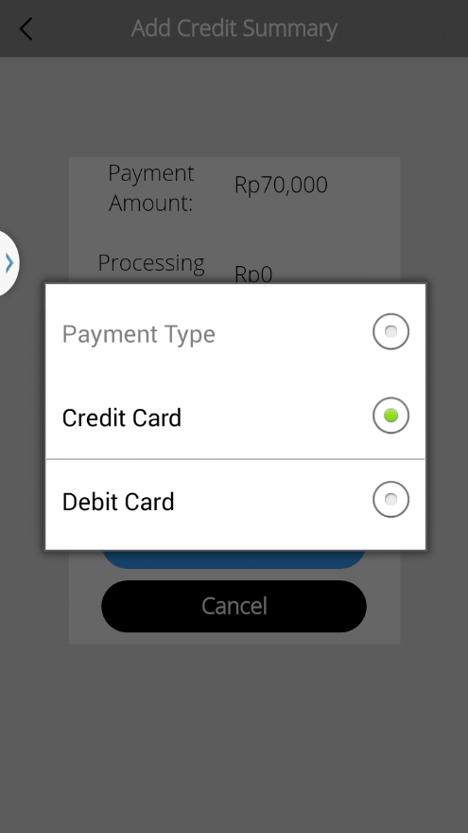 > 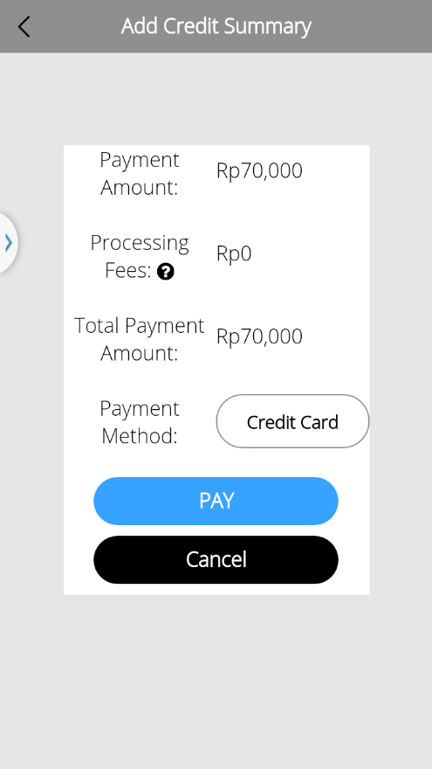 > 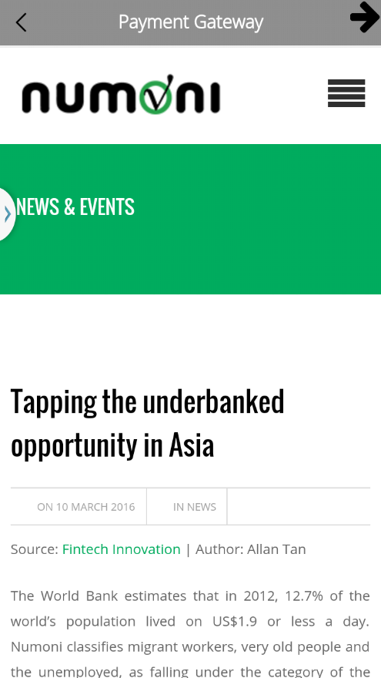 > 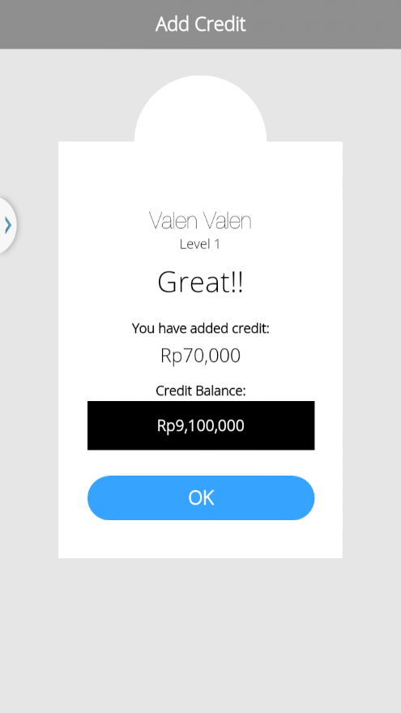 |  | I have not received this specification till now,  Nor have I received the API specification from Henny. as of 12 September 2016.  I will try to finish based on this specification with the API, when it comes.
 |  | Login > My Loans Portfolio  - UI differed from google drive, please refer to URL https://drive.google.com/drive/folders/0B9oOsWhCXi98b1FxVVB5S0lwRjg  - Please confirm other screens too  - Selected label being truncated.  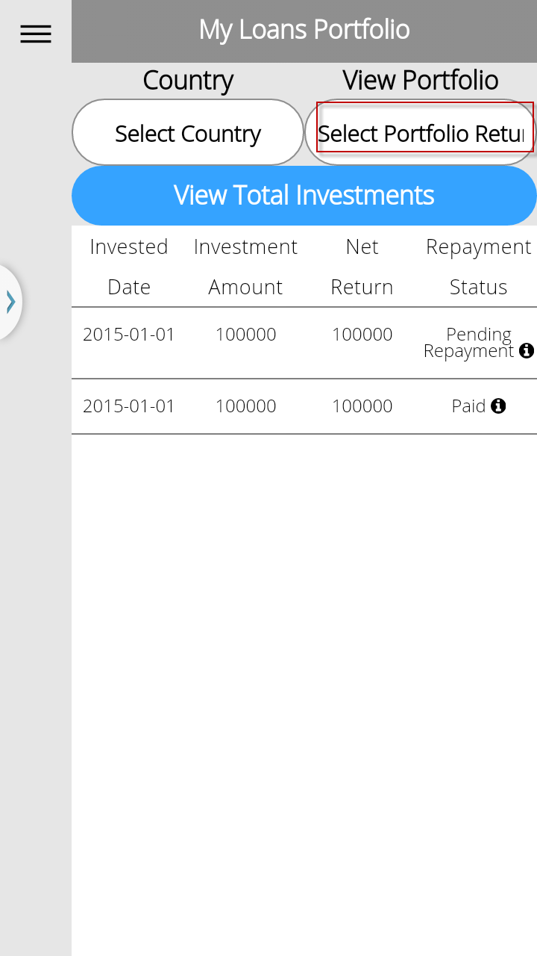 ≠ 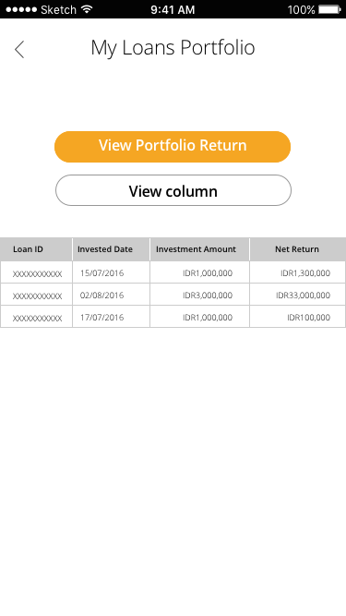 |  | I have not received this specification till now,  Nor have I received the API specification from Henny. as of 12 September 2016.  I will try to finish based on this specification with the API, when it comes.
 |  | Login > Transaction History  - UI differed from google drive, please refer to URL https://drive.google.com/drive/folders/0B9oOsWhCXi98b1FxVVB5S0lwRjg  - Please confirm other screens too  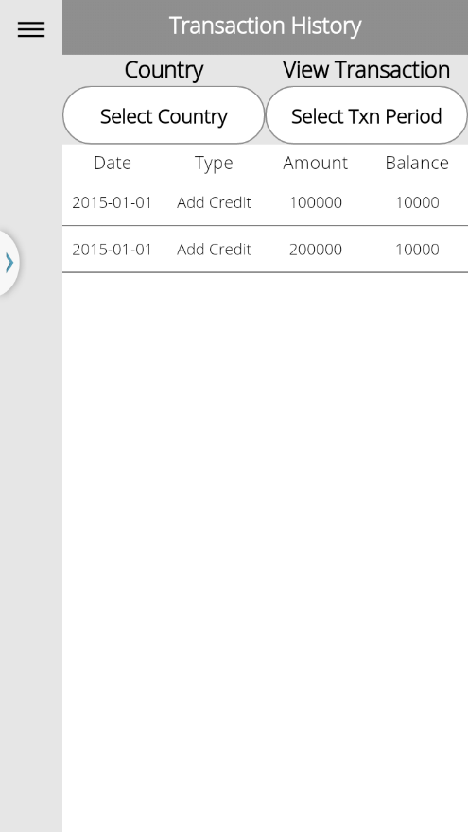 ≠ 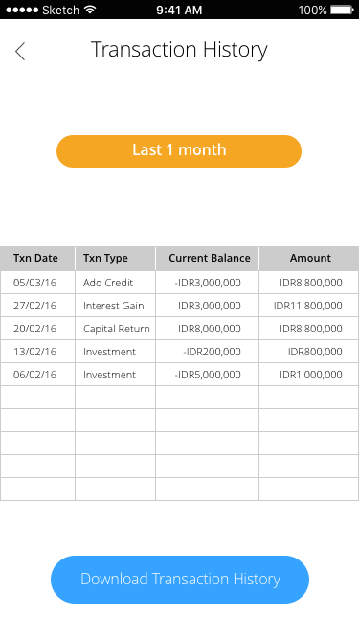 |  | I have not received this specification till now,  Nor have I received the API specification from Henny. as of 12 September 2016.  I will try to finish based on this specification with the API, when it comes.
 | Android/IOS | Login > Contact Us / FAQ  [13/09/16] no space between words.  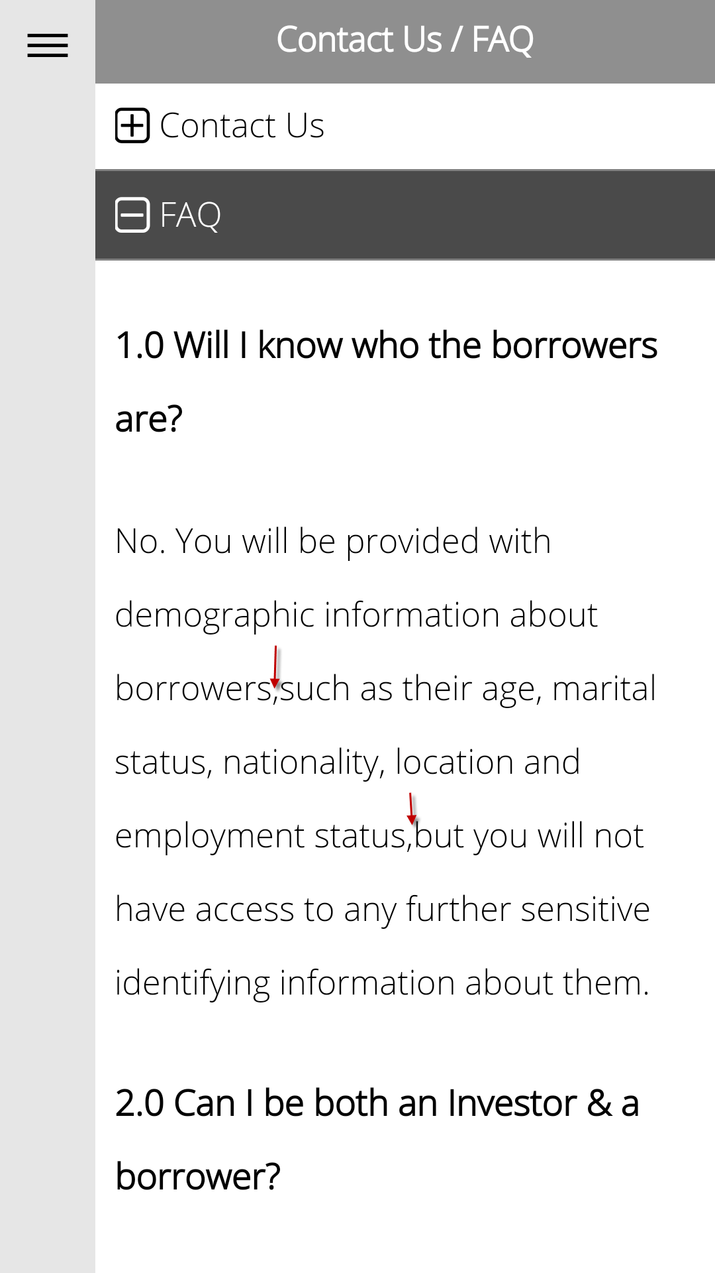 > 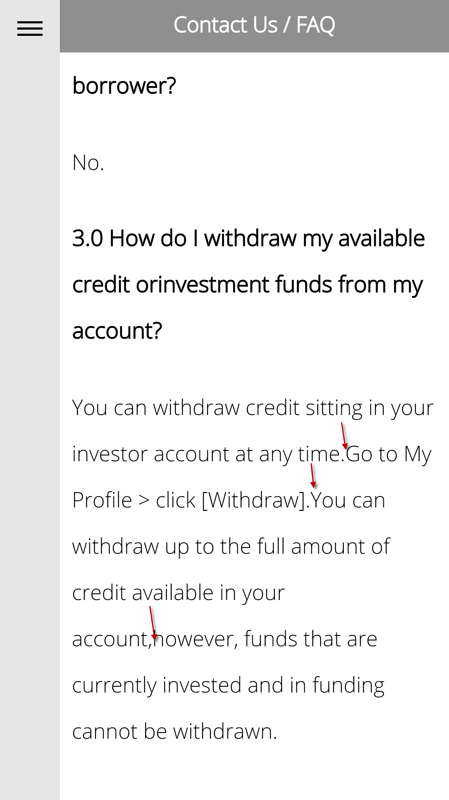 |  | I did not receive this specification till right now, as of 12 September 2016.  I will try to finish based on this specification.  [Valen] The UI design released on 05/09, please do not make such statement.  Brian: Ms. Sit already spoke on this.  If you leave a letter in a post office for a recipient to pick up, but do not notify the recipient that the letter is present, it counts as non-delivery: the letter is stuck in the post office.  Same goes for Google Drive, given that the software does not give notifications of new files added, directly to affected user. Furthermore, many file updates are made to our Google Drive, causing any history of files added to obscure important deliveries such as this.  Next time, WhatApp/Email/SMS will do.
 |  |  | Searching Criteria
11/09/16 |  | Searching of Loan Amount sometimes displayed Rp100, sometimes $100  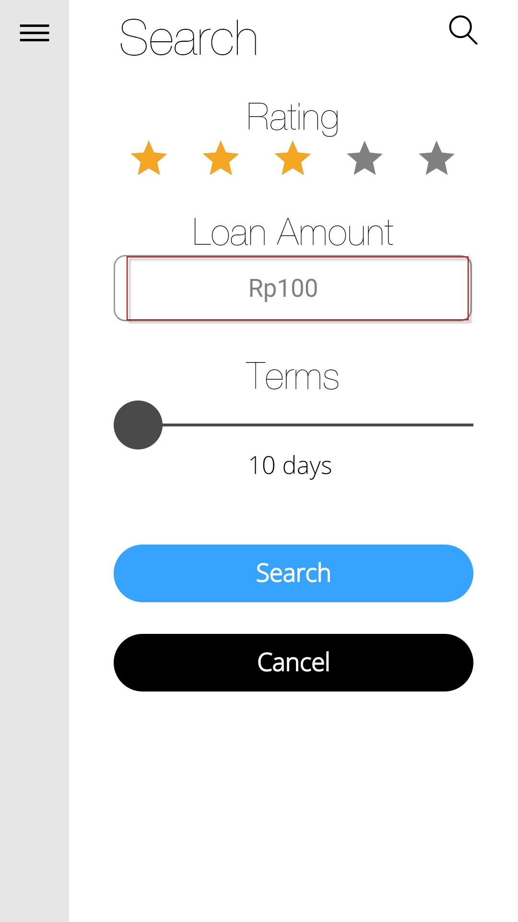≠ 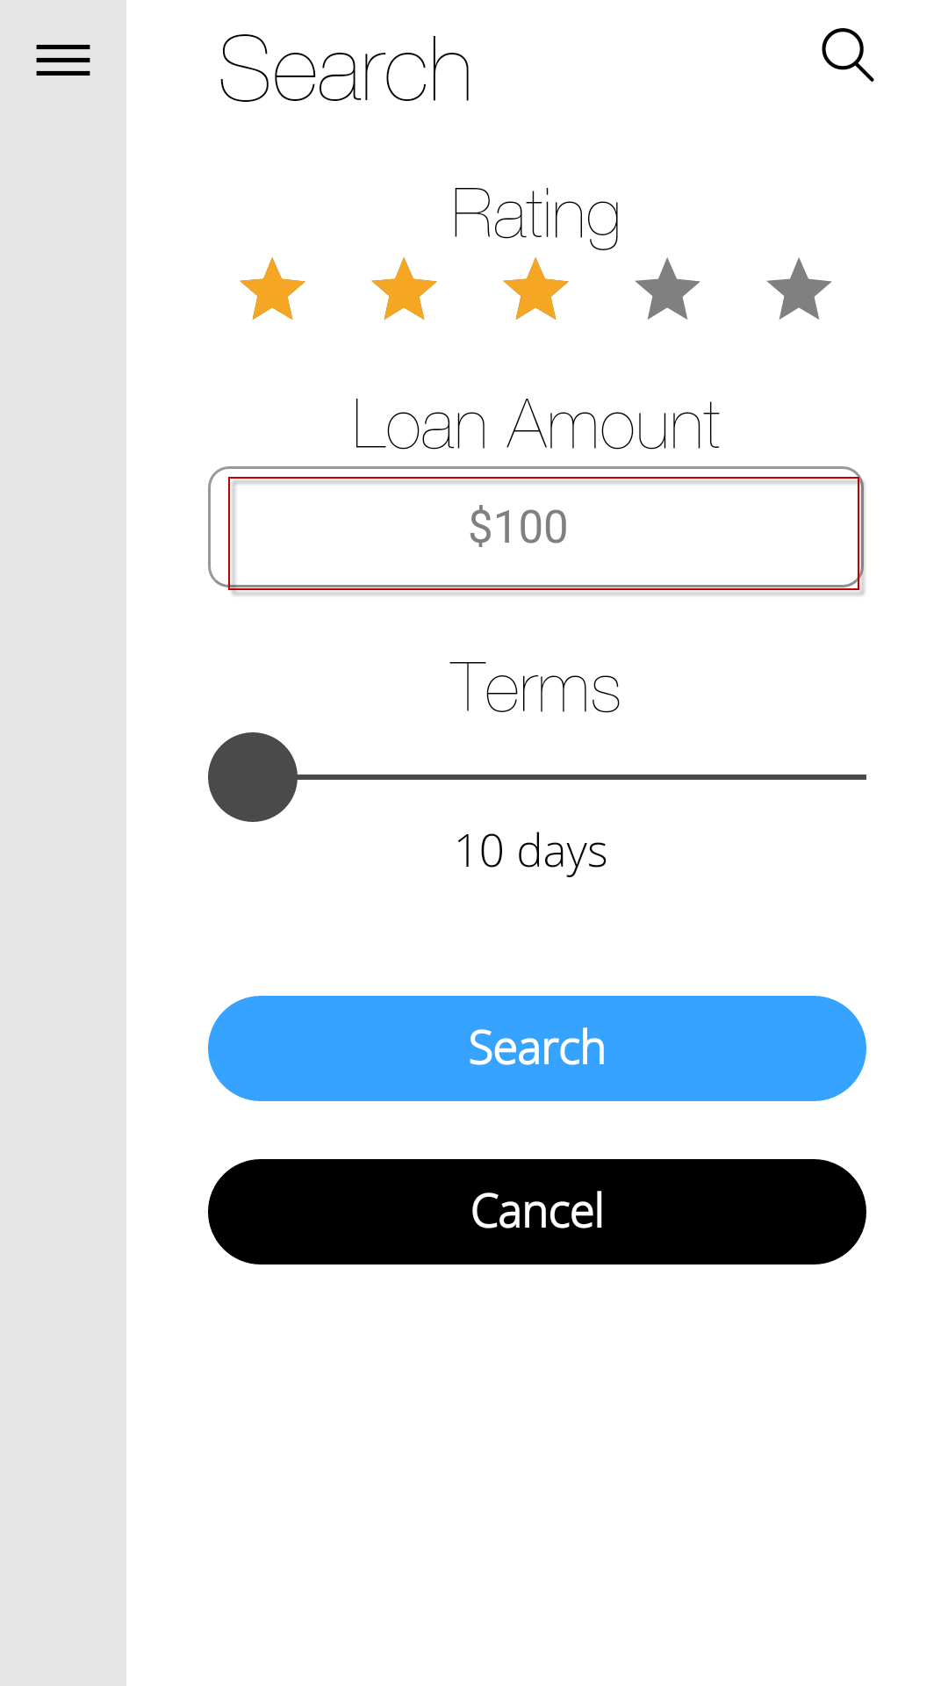  Loan Amount allow alphabet??  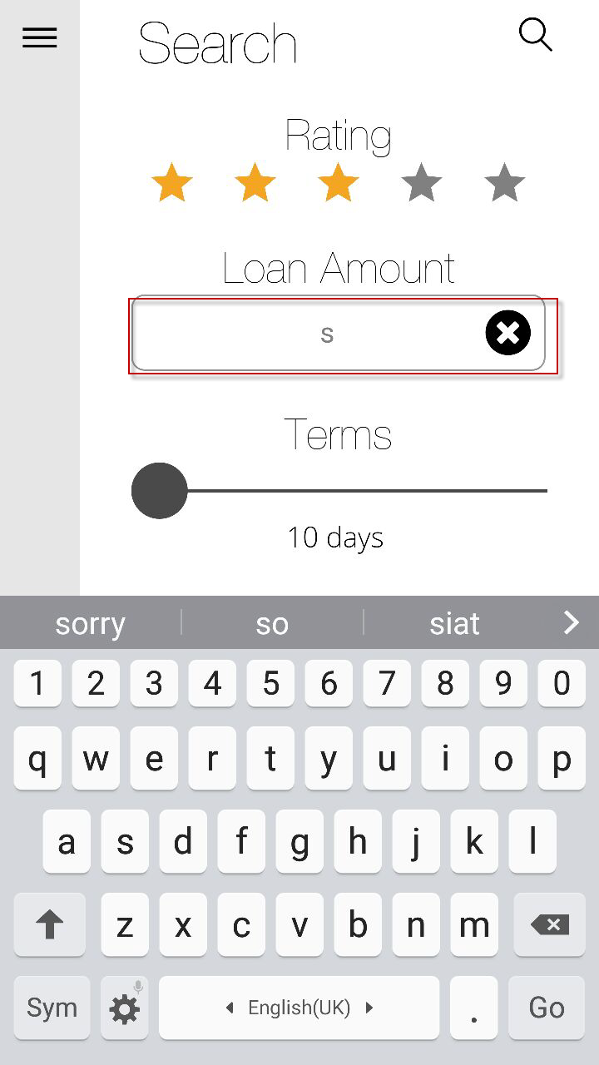 |  | Loan Amount Does not Allow Alphabet. It is programmed to reject alphabets, and reset the input field if any characters other than numbers are entered.  When user is not logged in, default currency is USD. How should we resolve different currencies involved?  Henny: Country API suggested, where we search based on countries. Add additional field for countries.  During login as registered USER /GUEST, return list of available countries user can search.
 |  | Search > Default page of search displayed > Input $10,000 but Loan Amount value displayed $100,010,000.  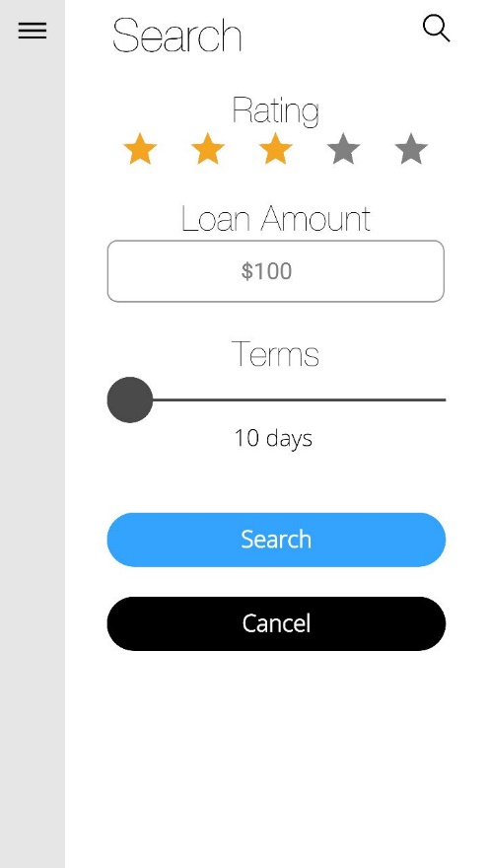 > 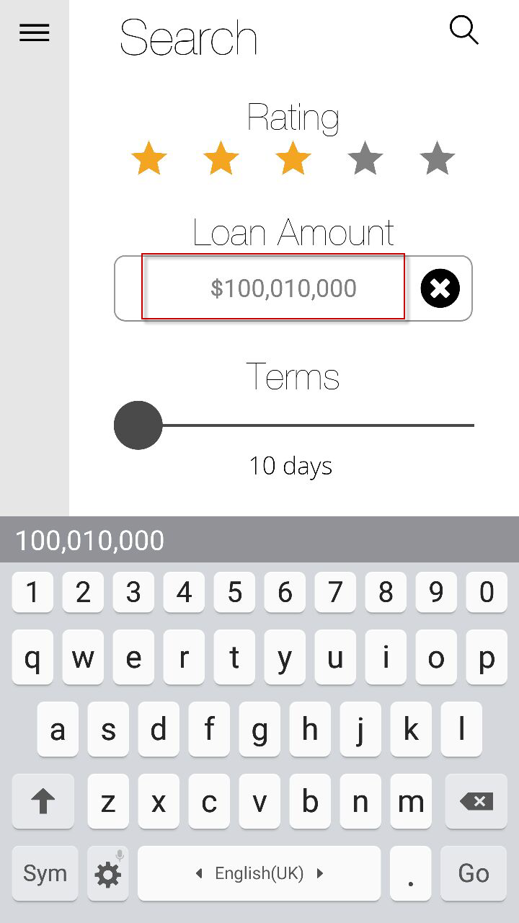  Search > Input $3,000 but Loan Amount value displayed $33,000.  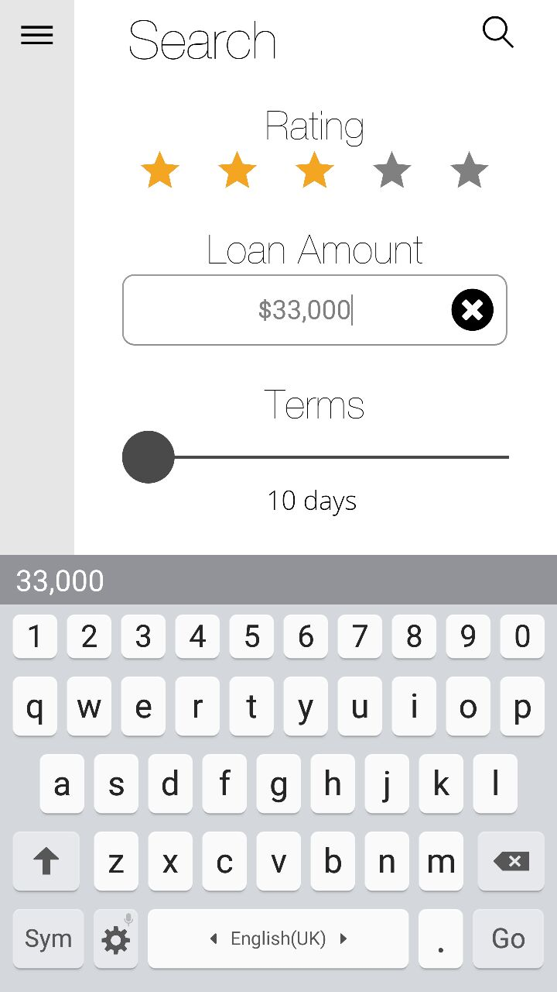 |  | I have not been able to replicate this on my phones (Samsung Mini J, Galaxy Note). However, some keyboards that have autocomplete on them do affect input, despite disabling such function on cordova side. Need further testing.  [Valen] We are unable to control whether the investor off the predictive text, we shall disable this when investor inputs the loan amount.
14/09/16 | Android/IOS | Search > Terms (duplicated 10 days found)  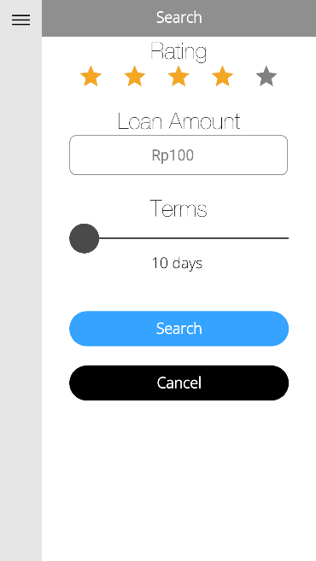 > 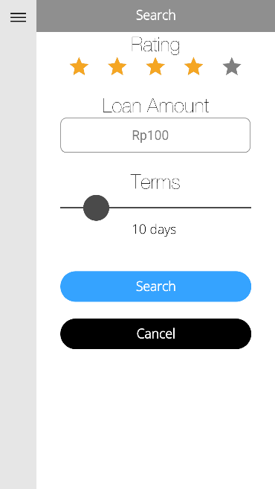 > 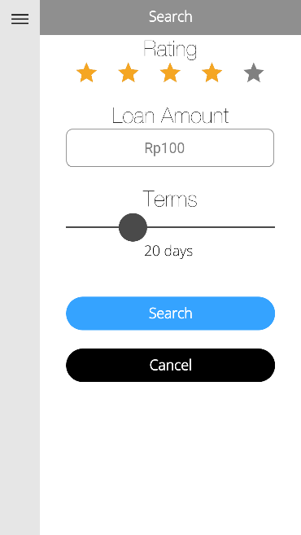 |  | DONE

